Simplex CNC
Simplex CNC – Motion Graphics Promotional Video
Project Description:
This project is a motion graphics promotional video created to introduce and showcase the capabilities of Simplex CNC, a company specialized in CNC machining and advanced manufacturing solutions. The video aims to communicate the company’s value, services, and technological expertise through engaging visual storytelling and dynamic motion design.
The video will present Simplex CNC as a modern and reliable partner in the manufacturing industry by highlighting its precision engineering, advanced CNC technology, and commitment to quality and innovation. Through a combination of animated typography, industrial-style graphics, machine illustrations, and smooth transitions, the video will simplify complex manufacturing concepts and transform them into clear and visually appealing information.
The motion graphics style will follow a clean, modern, and technical visual identity inspired by industrial design. Elements such as geometric shapes, mechanical movements, blueprint-style graphics, and animated icons will be used to represent the engineering and manufacturing processes involved in CNC production.
The video will be approximately 60–90 seconds long and structured in a storytelling format that includes an engaging introduction, an overview of the company and its services, a highlight of its technological advantages, and a strong closing message that reinforces the brand identity of Simplex CNC.
This project demonstrates the ability to combine design, animation, and storytelling to produce a professional motion graphics video that can be used for marketing, branding, and digital communication purposes within the industrial and engineering sectors.
Project Objectives:

- Present Simplex CNC and its services in a clear and engaging visual format.
- Use motion graphics to simplify complex industrial and engineering concepts.
- Demonstrate professional motion design skills including typography animation, transitions, and visual storytelling.
- Create a high-quality promotional video suitable for digital marketing and social media platforms.
Target Audience:
Manufacturing companies, industrial partners, engineers,Workshops, and businesses looking for high-precision CNC machining solutions.
Tools Used:
Adobe Illustrator (for graphic design and vector assets)
Adobe After Effects (for animation and motion graphics production)
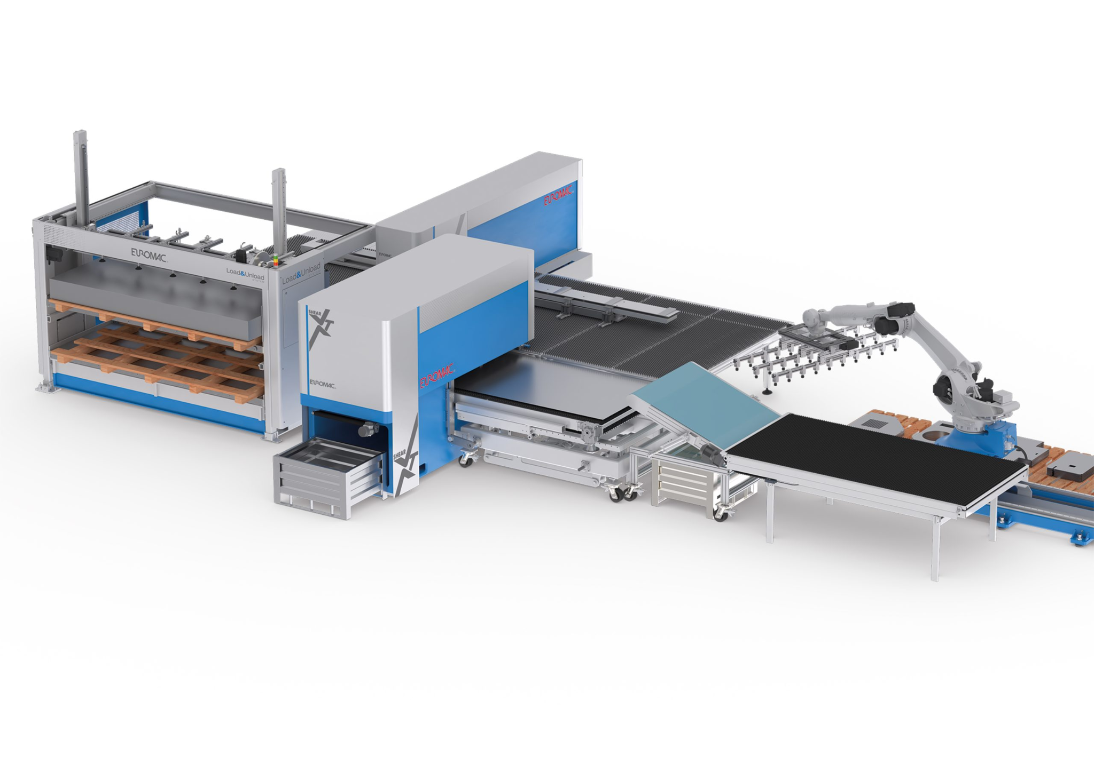
Final Output:
A 60–90 second motion graphics promotional video introducing Simplex CNC and its manufacturing capabilities.

